District Institute of Education and Training
Uthamacholapuram, Salem – 636 010.

- Important discussions Made in the CRC Meeting:
Faculty members of DIET Salem visited CRC meetings and made observations. During the observation following discussions were occurred in the meetings.
Name of the CRC: GHSS Maniyanoor,GHS Kaminaikanpatti
- Importance of EMIS Orientation
- CVC words - Relay story using CVC words-CVC word game
- The concentration of conversation of the students
- Personality games were identified and some were practiced.
- Right or wrong spoken English must follow in the classroom
- The function of TNSED Schools and App Feedback and Quiz in This App

Name of the CRC: T.Konagappdi & Chinnapillaiyur
- The training started with a clap & snap activity
- Sharing personal experiences with them to get rid of their fear of English.
- Videos of 26 letters phonics sounds were shown to teachers
- All the teachers practiced phonic sounds very interestingly.
- Teachers were given more activities as I spy, You see.
- Spoken English Demonstration 👍transaction Video -1 & 2 played
- Personality identifying game is conducted.
- Using CVC Words teachers practiced relating stories, chant, and sentences
- Tricky words were introduced.
- Ice break activity is introduced with a number of adjectives.

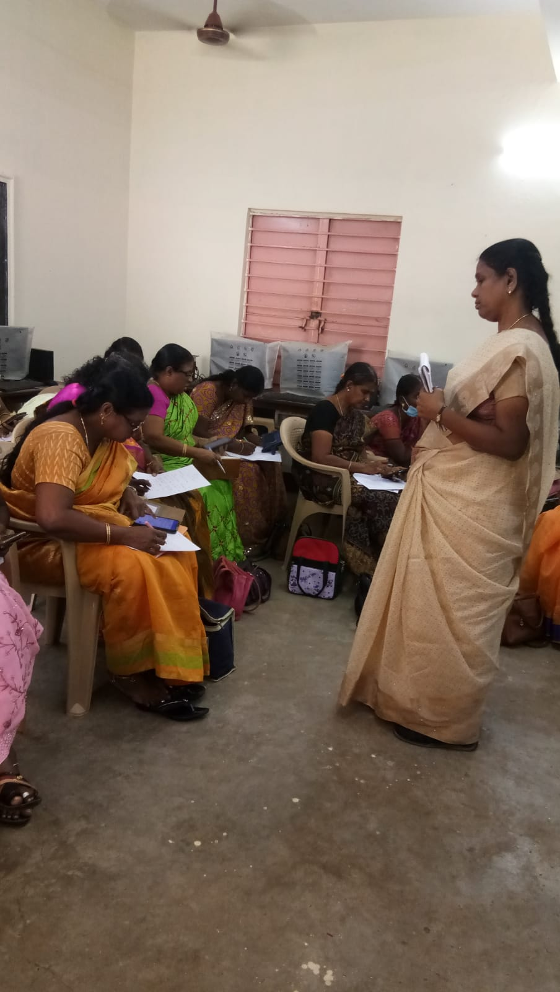

Name of the CRC: Kamaraj Girls Hr. Sec. School
- To get practice in speaking English inside the classroom
- Teach simple sentences to students during class hours.
- Ask the students to read and watch English news Paper and News T.V Channels
- Teachers and students have an informal interaction session every day with students.
- During the prayer hour usage of proverbs must be included.
- Practice students themselves talk in English within the classroom and school campus.
Name of the CRC : GHSS, Murungapatty (03.12.2022)
- Phonics sound for the given alphabet
- Formed words for the Phonics sound
- Sang a phonics song
- Played a game” I spy you see”
- Formation, Importance and Pattern of CVC words
- Chants on CVC words
- Wrote stories using only the CVC words
- CVC words for a given topic
- EMIS orientation
- TNSED app – doubt clearance
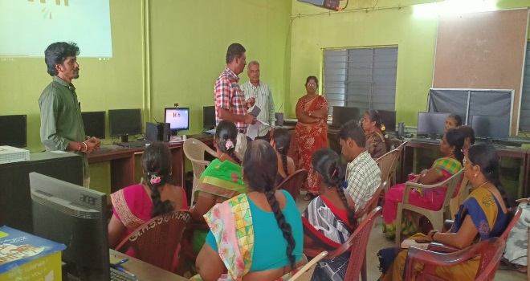
Name of the CRC:GHSS Udayapatti
- Sharing the personal experience of transaction spoken English plans by the facilitator
- CTC (commencement, transaction & conclusion) by the facilitator.
- Teachers discussed practical difficulties in the classroom and also discussed the remedies.
- Tamil, English & Maths bridge course content discussed.
- EMIS orientation
Name of the CRC:GHSS Vellalapatti & GHSS Karupur, Omalur
- Strategies for giving mor activities to improve English language
- Simple way of teaching grammar
- Play way method of improving English spoken
- Interrelating language skills with other subjects
- Usage of workbook for content enrichment
- Utlising Ellam Thedi Kalvi resources for student improvement
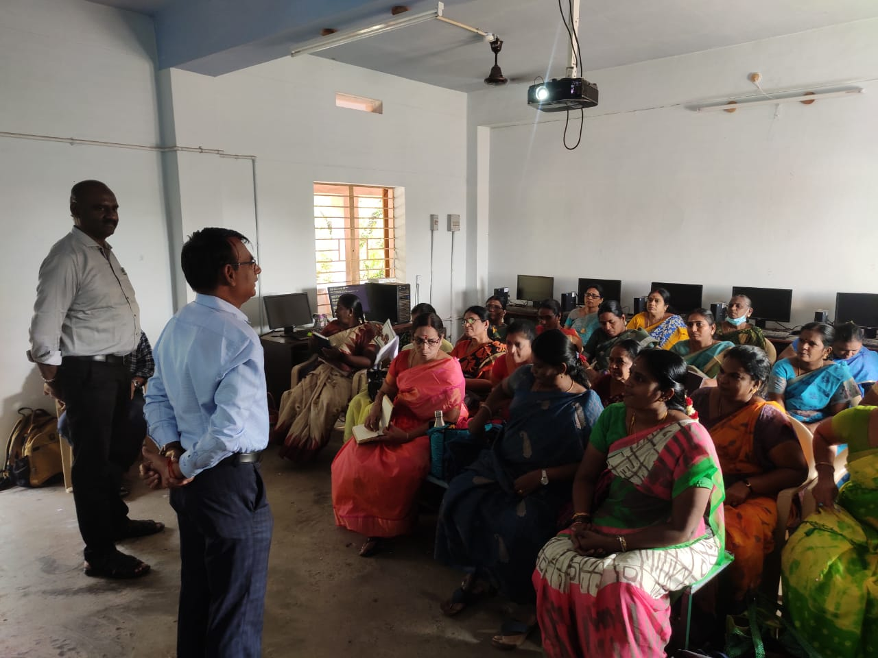

Name of the CRC: Edappadi
- spoken English
- phonics sounds, words
- vocabulary development
- EMIS
- CVC words
- Videos for motivation and content developement
Name of the CRC: GHSS Gangavalli
- Covit 19 காலகட்டத்திற்கு பின் மாணவர்கள் செயல்பாடுகள்
- கற்றல் கற்பித்தல் வலுவூட்டும் செயல்பாடுகள்
- மெல்லக்கற்போர் மீது கூடுதல் கவனம்
- பாடப்பொருளை முழுமையாக மாணவர்களுக்கு புரிதல் சார்ந்த செயல்பாடுகள்
- ஆசிரியர் மாணவர் தோழமை உணர்வு
- துணைக்கருவிகள் பயன்பாடு
- வினாக்களை வடிவமைக்கும் திறன்( உயர் சிந்தனை வினாக்கள்)
- மன வரைபடம்
- எண்ணும் எழுத்தும் பயிற்சி வலுவூட்டல்

- Suggestions were given by the DIET Faculty:
During observations to facilitate the meeting following suggestions were given by DIET faculty members
Name of the CRC: GHSS Maniyanoor,GHS Kaminaikanpatti
- Same activities repeat and reinforce the concept to the students
- Concentrate CRC activities in F(a) activities
- Concentrate on creative activities in the classroom situation

Name of the CRC: T.Konagappdi & Chinnapillaiyur
- Encouraged the teachers to talk in English.
- Advised the teachers to participate in all activities.
- Motivate the teachers to make the students skillful in the English Language.
- A minimum number of teachers were assembled in the CRC Centre ( at least 30)
Name of the CRC: Kamaraj Girls Hr. Sec. School
- Teachers must prepare themselves to talk in English during class hours among students
- Teachers among themselves must be aware of the vocabulary words.
- Teachers should practice a debate on English topics.
- Teachers to conduct Oratorical competitions in English-language.
- Winners may be awarded special prizes to students.
Name of the CRC : GHSS, Murungapatty (03.12.2022)
- Try to speak in English in the classroom transactions
- Introduce CVC words in the classroom
- Help the students to listen and list out too many words on a given sound
- Adopt different strategies for listening and speaking to improve English speaking skill
Name of the CRC:GHSS Udayapatti
- Ask the students to try to talk English in the classroom.
- Improve students' vocabulary through games.
- Motivate students to read newspapers and storybooks.
- Encourage students to frame a small sentence.
Name of the CRC:GHSS Vellalapatti, Omalur
- Game oriented activities for language development
- Personality development through Ennum Ezhuthum activity carners
- Relating real life situations to the content.
- Activities should be framed to reach Learning Outcomes
- Assessment through EMIS portal
Name of the CRC: GHSS Gangavalli
- மெல்லக்கற்போர் மீது தனி கவனம் செலுத்தி மாணவர்களின் கற்றல் அடைவை மேம்படுத்துதல்
- எண்ணும் எழுத்தும் வகுப்பறைகளில் முழுமையாக கொண்டு சேர்த்தல்
- ஆசிரியர்கள் பாடபொருளை சார்ந்து கலந்துரையாடல் செய்தல்
- Covit 19 காலகட்டத்திற்கு பின் மாணவர்களை உளவியல் ரீதியாக அணுகுதல்

